
PACKT Template Style List
This document contains a list of the styles in the Packt template, and an indicator of their typical use. You can access these styles from the Quick Access Toolbar in the Home tab:
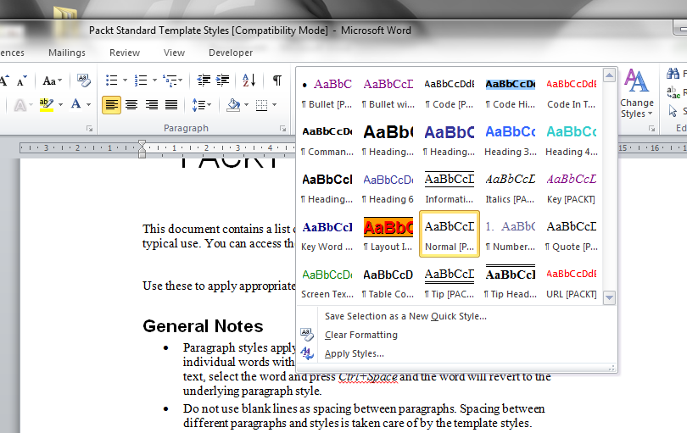
Use these to apply appropriate styling to the content you are writing.

Essential styles to use
The Packt writing template features a large number of styles for different kinds of content. These styles help make our final books easier to follow. Most styles are not necessary during first drafts although some authors like to apply them as they go. It’s up to you.
Some styles are so important that it’s worth using them even in the first draft. These are:
- Heading styles, which give overall structure to the document.
- Code and Code Highlighted styles, which mean blocks of code are in a fixed-width font.
- The Layout Information styles, which are necessary for our internal processes.
- The Information Box style, which lets you share short blocks of text separately from the main flow of the chapter – or just make key points stand out.
For numbered and bulleted lists you can either use the Packt styles or the built-in list feature, whichever is easier for you. In the first draft it’s fine to use the built-in bold and italic formats, but in the final book we will replace these with the appropriate Packt style.
You do not need to use any other styles in your first draft but you can if you choose to. Bear in mind that any formatting you do will be replaced with the appropriate Packt style later, so please do not attempt any complex formatting as you write your chapter.
You’ll see each style explained in more detail later in this document.

How styles work
In case you’ve not used styles much before, here’s some background:
- Paragraph styles apply to the entire paragraph – Character styles apply to individual words within a paragraph. To remove a Character style from your text, select the word and press Ctrl+Space and the word will revert to the underlying paragraph style.
- Do not use blank lines as spacing between paragraphs. Spacing between different paragraphs and styles is taken care of by the template styles.
- OpenOffice users: The [PACKT] styles can be found in the style list by viewing the Custom Styles. However, the heading styles in your template do not show the [PACKT] suffix, and the ordinary heading styles, Heading 1, Heading 2, etc. are used. These do not show in the Custom Styles view unfortunately.
- If you wish to make notes for the editors, add a comment to the document using Word's comment feature or Open Office's notes feature.

The Packt Styles
Note that all of the styles are followed by the word [PACKT] in their style name in the template.
Styles other than the [PACKT] styles should not be used in your document without prior consultation with your editor. Do not manually change fonts and layout, please use the [PACKT] styles instead.

Packt Character Styles
These styles apply to individual words or phrases within a paragraph.
Name & Shortcut | Typical Use and Look
Code In Text [PACKT] | Code within text, including file and directory names, but not URLs.
Key [PACKT] | Keyboard keys, such as Ctrl+X.
Key Word [PACKT] | Important words, mostly technical terms, that need emphasizing. Typically used for the first appearance of an important term.
Italics [PACKT] | Phrases, clauses, or sentences that need emphaszing
Screen Text [PACKT] | Text that is displayed on the screen, such as an application button’s text.
URL [PACKT] | Used to mark real URLs within text, such as www.google.com.  You should use URL [PACKT] for a URL that a reader could click and actually go to a real site. For example, localhost/mysite.html would be Code In Text [PACKT] since that page need not exist.

Packt Paragraph Styles
These styles apply to complete paragraphs.
Name & Shortcut | Typical Use and Look
Bullet [PACKT] | - List of things that are better presented as bullets
Bullet without Bullet [PACKT] | Indented paragraph, used for an item in a bulleted or numbered list where there is no bullet mark or number.  This style is marked as Indent on the Packt Paragraph toolbar.
Chapter Number [PACKT] | Chapter number (not shown here, it is large!)
Chapter Title [PACKT] | Chapter title (not shown here, it is large!)
Code [PACKT] | Code (including console output)
Code Highlighted [PACKT] | Highlighted code within code
Command Line [PACKT] | Style used to show command-line input. Use the appropriate prompt symbol.
Heading 1, Heading 1 [PACKT] | First-level Section Heading
Heading 2, Heading 2 [PACKT] | Second -level Section Heading
Heading 3, Heading 3 [PACKT] | Third-level Section Heading
Heading 4, Heading 4 [PACKT] | Fourth-level Section heading
Information Box [PACKT] | Used to highlight important notes to the reader.
Layout Information [PACKT] | Used to identify images within a document
Normal [PACKT] | Any text that does not qualify for one of the other styles.
Numbered Bullet [PACKT] | - List of things that are better presented as bullets and whose number is significant.
Quote [PACKT] | Style for adding quotations from other sources
Table Column Heading [PACKT] | Table column headings
Tip Heading [PACKT] | Headings for tips/commonly asked questions
Tip [PACKT] | Tip contents/answers to commonly asked questions

